(Essay) TITLE - PUT THE TITLE IN THIS PLACE IN CENTRAL UPPERCASE - MAXIMUM 14 WORDS

Author 1
Orcid
Ex.: Universidade Federal do Pampa, Curso de Serviço Social, São Borja/RS - Brasil
xxxx@unipampa.edu.br

Author 2
Orcid
Ex.: Universidade Federal do Pampa, Curso de Serviço Social, São Borja/RS - Brasil
xxxx@unipampa.edu.br

if necessary, insert other authors here following the examples shown above

Received on: Leave Blank
Accepted on: Leave blank

Abstract: The abstract must be written in the third person singular, with the verb in the active voice in a single paragraph with justified alignment, without indentations. It must not present bibliographic citations, formulas, equations, diagrams or symbols. It should be clear, concise and contain the objectives, methodology, results and conclusions of the research. Its extension must have between 100 and 200 words, with single space between lines, font size 10, type Arial. In the case of texts submitted in English and Spanish, a summary must be made in the language of the text and the summary in Portuguese. Three to five keywords should be listed, separated by semicolons and should not repeat words already used in the title.

Keywords: List between three and five; Separated by semicolons; First letter capitalized; Followed by full stop.

TITULO

Resumo: Deverá traduzir fielmente o resumo. Os autores poderão escolher se desejam traduzir para o inglês ou para o espanhol. Ressalta-se que a tradução deverá ser realizada por um tradutor habilitado em detrimento de tradutores online disponíveis na internet. Assim como o resumo, sua extensão deve ter entre 100 e 200 palavras, formatado com fonte Arial tamanho 10, espaçamento entre linhas simples e alinhamento do parágrafo justificado sem recuos.
Palavras-chave: Tradução das palavras-chave; Separadas por ponto e vírgula; Primeira letra maiúscula; Seguidas de ponto final.

The essay must contain the following structure:
Introduction;
Development that can be divided into two or 3 sections;
Final considerations;
References.

Text: Paragraphs without indentation, Arial 12 font, with 1.5 line spacing, without spaces before and after paragraphs. Top and left margins 3 cm and bottom and right 2 cm.
Pages: the minimum must be (15) fifteen pages and must not exceed 20 (twenty), including tables, figures, bibliographic references and endnotes of the text;

The essay text may be divided into sections (unnumbered, in capital letters and in bold; Example: INTRODUCTION, METHODOLOGY, RESULTS AND DISCUSSION) and subsections (not numbered, with capital only in the first letter and in the proper names, in bold and italics; Example: Study area). The first section will always be the INTRODUCTION. This section should include the objectives, hypotheses (if any) and justification of the work.
For all software mentioned in the text, the following must be included: if it is commercial, the license information of the same; if free, you must cite this information in the text; the software must also appear in the references.
Follow the models below to create Figures and Tables in the text (further guidelines are available on the Journal's website, under “Guidelines for authors”).
For citations throughout the text, use the following formatting: One author: Ab'Saber (1990) or (AB'SABER, 1990). Two authors: Silva and Ramirez (1992) or (SILVA; RAMIREZ, 1992). Three authors: Lima, Mendes and Santos (2017) or (LIMA; MENDES; SANTOS, 2017). Four or more authors: Silva et al. (1992) or (SILVA et al., 1992).
Use semicolons to separate citations from different authors (SILVA and RAMIREZ, 1992; RAMIREZ, 1993) or for multiple citations from the same author (AB'SABER, 1990; 1993a; 1993b). Present multiple citations in chronological order (AB'SABER, 1990; SILVA and RAMIREZ, 1992; AB'SABER, 1993).

For long direct quotes, use the following formatting: 4cm indent, single spacing, ARIAL 9, separated from the upper and lower text by 6 pt spacing. (AUTHOR, YEAR, PAGE).

● Figures (the elements inside the figures must all be legible): photographs, drawings, graphs, images, maps, etc. will all be called figures. Figures must be inserted into the text as images and not imported from Excel.

Upper text (Figure 1).
Figure 1 – The title (centered, with Arial 10 font) must contain the following elements, in this order: Location – figure description – date. The titles must not be inside the Figures (they must be at the top of the figure, in the form of text, as shown in the example below).

Figure 1: Distribution of ICU Beds 2020 - RS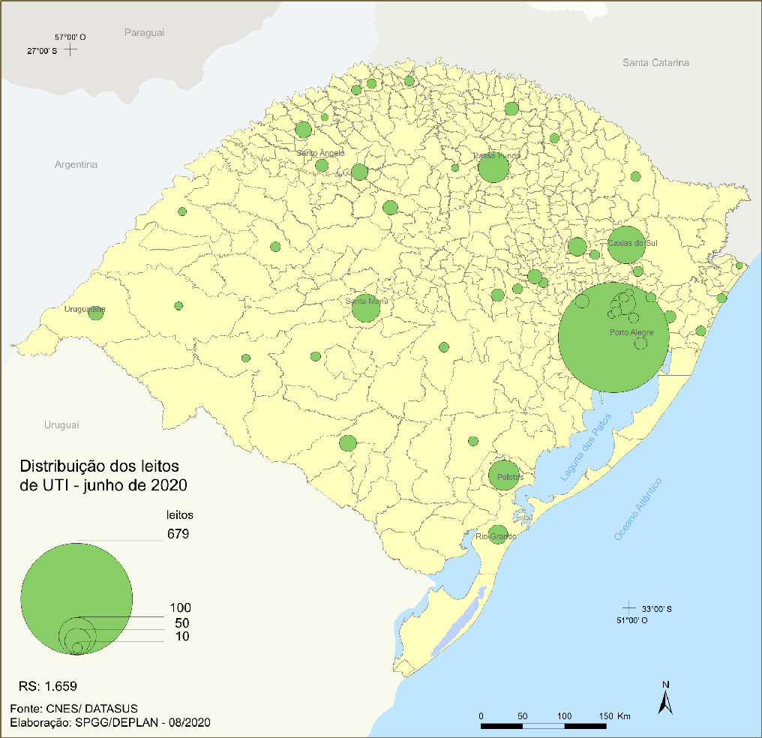
Source: Socioeconomic Atlas of Rio Grande do Sul (2021, p. 94). Elaboration or Organization: Planning, Governance and Management Secretariat. Department of Government Planning, 2021. In the case of manuscripts, insert only authors, aiming at blind review (centralized, with Arial 10 font)

The sources of the figures must appear in the references

Text … always cite tables, figures and other items in the text, and then insert them. As shown in table 1.

Tables (avoid saving them as images, but rather elaborated in the text, or exported from excel): tables are open on the sides

Upper text (Table 1) ...

Table 1 - Evolution of the HDI of Rio Grande do Sul - 1991/2000/2010
 | 1991 | 2000 | 2010
Total | 0,542 | 0,664 | 0,746
Renda | 0,667 | 0,720 | 0,769
Longevidade | 0,729 | 0,804 | 0,840
Educação | 0,328 | 0,505 | 0,642
Source: Socioeconomic Atlas of Rio Grande do Sul (2021, p. 81). Elaboration or Organization: Planning, Governance and Management Secretariat. Department of Government Planning, 2021. In the case of manuscripts, insert only authors, aiming at blind review (centralized, with Arial 10 font)

The Frames (avoid saving them as images, but rather elaborated in the text, or exported from excel): The frames are closed on the sides

Text … always cite tables, figures and other items in the text, and then insert them. As shown in table 1.

Table 1 - The dimensions that make up the HDI
Dimension | Concept
Income | standard of living measured by gross national income per capita
Health/Longevity: | healthy and long life as measured by life expectancy;
Education: | access to knowledge measured by the average years of adult education and expected years of schooling for children of starting school age
Source: Socioeconomic Atlas of Rio Grande do Sul (2021, p. 81). Elaboration or Organization: Planning, Governance and Management Secretariat. Department of Government Planning, 2021. In the case of manuscripts, insert only authors, aiming at blind review (centralized, with Arial 10 font)

Bottom text...

two spaces before
FINAL CONSIDERATIONS
one space later
After the text of the article, the authors must elaborate their final considerations. They should be brief and answer the research questions raised in the introduction, corresponding to the objectives and hypotheses (when they exist), and point out the main contributions of the research, and may present recommendations for future work.

two spaces before
THANKS
one space later
Acknowledgments are recommended for works that are the result of academic research with funding, whether national or international, as well as those linked to government agencies.
It is noteworthy that this item is optional for the authors.

two spaces before
REFERENCES
one space later
References must follow the ABNT standards in force, with some essential observations, such as:
- Alphabetical order
- Left aligned
- Single space, with 6 dots before and after each reference
- Insert the research links (electronic sites), with access date and DOI of the works to facilitate their location.
- Follow the recommendations provided in the Reference Standardization manual of the UNIPAMPA library system, available at: https://sites.unipampa.edu.br/sisbi/normalizacao/ .

Examples:
ARAÚJO, Cátia Rosana L. de; MARQUES, Dilva Carvalho. Manual de normalização de citações, sistemas de chamadas e notas de rodapé. Bagé: Universidade Federal do Pampa, 2021. 17 p. il. Disponível em: https://sites.unipampa.edu.br/sisbi/normalizacao/ . Acesso em 17/02/2022.
ÁVILA, M. B. Direitos sexuais e reprodutivos: desafios para as políticas de saúde. Cadernos de Saúde Pública, Rio de Janeiro, v. 19, p. 465-469, 2003. DOI.
BRASIL. Medida Provisória nº 2.230, de 8 de setembro de 2001. Disponível em: https://www.planalto.gov.br/ccivil_03/MPV/Antigas_2001/2230.htm Acesso em: 04 de setembro de 2008. DOI.
FREYRE, G. Casa grande & senzala: formação da família brasileira sob regime de economia patriarcal. Rio de Janeiro: J. Olympio, 1943. 2 v. DOI.
______ . Sobrados e mucambos: decadência do patriarcado rural no Brasil. São Paulo: Ed. Nacional, 1936. DOI.
MINAYO, M. C. S.; GOMES, S. F. D. R. (Org.) Pesquisa social: teoria, método e criatividade. 30 ed. Petrópolis: Vozes, 2011. (Coleção Temas Sociais). DOI.
RIO GRANDE DO SUL. Atlas Socioeconômico do Rio Grande do Sul. Secretaria de Planejamento, Governança e Gestão. Departamento de Planejamento Governamental. – 6. Ed. – Porto Alegre: Secretaria de Planejamento, Governança e Gestão. Departamento de Planejamento Governamental, 2021. 203 p. Disponível em: https://atlassocioeconomico.rs.gov.br/inicial . Acesso em: 17.02.2022
SANTOS, M. A metrópole: modernização, involução e segmentação. In: VALLADARES, L.; PETRECEILLE, E. (Coord.) Reestruturação urbana: tendências e desafios. São Paulo: Nobel, 1990. p. 183-191. DOI.

In cases that were not covered by the rules described above, authors must follow the ABNT standards in force:
* References - Elaboration (NBR 6023);
* Citations in documents - Presentation (NBR 10520);

Author's name
Include here information about the authors, biography, a maximum of 10 lines for each author.
Example: PhD in Communication and Information from the Federal University of Rio Grande do Sul (UFRGS). Master in Communication Sciences from the University of Vale do Rio dos Sinos (UNISINOS). Coordinator of the Image Research Laboratory: photo, video, design and cinema (UFSM/CNPQ). Researcher in the research groups: Processes and Practices in Creative and Cultural Activities" (UNIPAMPA/CNPq); "Science, Health, Gender and Feeling" (Interdisciplinary Graduate Program in Human Sciences - PPGICH, University of Santo Amaro - UNISA/CNPQ ).

An essay is a piece of writing that describes, analyzes and evaluates a particular topic or problem. It is a short, concise form of writing that contains an introduction, a body that is made up of a few supporting paragraphs, and a conclusion. An essay can inform the reader, maintain an argument, analyze a problem, or elaborate a concept.

